Jaypee Institute of Information Technology



**TITLE:**

**SARS Cov-2 Vaccination System**

**Details of Team**

* Anurag Singh 19103150
* Divyansh Bhargava 19103127

(Both from B-4 Batch)

**Abstract of the project**

The project “SARS Cov-2 Vaccination System” is Computer Science model made using the applications of Data Structure and Algorithms.

As the name of this project suggests this model works for an objective to ease the vaccination drive for common people. In this system one can book a vaccination slot easily by uploading his/her details. The user will be asked to provide certain details regarding his/her identity and regarding the phase of vaccine he/she is applying for once the user is registered successfully, the system will display all the information regarding the location of the vaccination centres present nearby user and the user can book his/her slot for the vaccine depending on the availability of the vaccine on the particular centre which will also be displayed to the user at the time of booking.

Once the done with the selection of vaccination centre process the user will be registered for an automatic first come first jabbed vaccination process, the details of the same can be viewed in the waiting list, where user can remove the application if required due to some error in the application submitted and then that available slot will automatically be specified to the very next fellow present in the list.

Based on the phase and urgent need of some special case of user the preference can be given to him/her. It is possible that people who are applying for the vaccine under the foreign travel section might get the slot allotted earlier.

**Tools and Technologies used**

* C++ Language
* Vectors
* Queue
* Sorting
* Graphs

**DATASET(KAGGLE) and few test cases run from our side**

|  |  |  |  |
| --- | --- | --- | --- |
| **PATIENT ID** | **PATIENT NAME** | **PATIENT CONTACT NO.** | **Patient Phase** |
| 111 | Anurag | 12121 | 1 |
| 222 | Divyansh | 13131 | 2 |
| 333 | Ram | 14141 | 3 |
| 444 | Shyam | 15151 | 1 |
| 555 | Karan | 12123 | 3 |
| 666 | Arjun | 99999 | 2 |
| 777 | Sita | 16116 | 1 |
| 888 | Geeta | 13112 | 2 |
| 999 | Piyush | 11232 | 3 |
| 1110 | Devarshi | 12123 | 1 |
| 1221 | Kelly, Mr. James | 330911 | 1 |
| 1332 | Wilkes, Mrs. James (Ellen Needs) | 363272 | 2 |
| 1443 | Myles, Mr. Thomas Francis | 240276 | 2 |
| 1554 | Wirz, Mr. Albert | 315154 | 2 |
| 1665 | Hirvonen, Mrs. Alexander (Helga E Lindqvist) | 3101298 | 1 |
| 1776 | Svensson, Mr. Johan Cervin | 7538 | 3 |
| 1887 | Connolly, Miss. Kate | 330972 | 3 |
| 1998 | Caldwell, Mr. Albert Francis | 248738 | 1 |
| 2109 | Abrahim, Mrs. Joseph (Sophie Halaut Easu) | 2657 | 3 |
| 2220 | Davies, Mr. John Samuel | 48871 | 1 |
| 2331 | Ilieff, Mr. Ylio | 349220 | 2 |
| 2442 | Jones, Mr. Charles Cresson | 694 | 2 |
| 2553 | Snyder, Mrs. John Pillsbury (Nelle Stevenson) | 21228 | 1 |
| 2664 | Howard, Mr. Benjamin | 24065 | 3 |
| 2775 | Chaffee, Mrs. Herbert Fuller (Carrie Constance Toogood) | 5734 | 2 |
| 2886 | del Carlo, Mrs. Sebastiano (Argenia Genovesi) | 2167 | 1 |
| 2997 | Keane, Mr. Daniel | 233734 | 2 |
| 3108 | Assaf, Mr. Gerios | 2692 | 3 |
| 3219 | Ilmakangas, Miss. Ida Livija | 3101270 | 1 |
| 3330 | Assaf Khalil, Mrs. Mariana (Miriam")" | 2696 | 1 |
| 3441 | Rothschild, Mr. Martin | 17603 | 2 |
| 3552 | Olsen, Master. Artur Karl | 17368 | 2 |
| 3663 | Flegenheim, Mrs. Alfred (Antoinette) | 17598 | 2 |
| 3774 | Williams, Mr. Richard Norris II | 17597 | 3 |
| 3885 | Ryerson, Mrs. Arthur Larned (Emily Maria Borie) | 17608 | 1 |
| 3996 | Robins, Mr. Alexander A | 53337 | 3 |
| 4107 | Ostby, Miss. Helene Ragnhild | 113509 | 1 |
| 4218 | Daher, Mr. Shedid | 2698 | 2 |
| 4329 | Brady, Mr. John Bertram | 113054 | 2 |
| 4440 | Samaan, Mr. Elias | 2662 | 1 |
| 4551 | Louch, Mr. Charles Alexander | 3085 | 3 |
| 4662 | Jefferys, Mr. Clifford Thomas | 31029 | 2 |
| 4773 | Dean, Mrs. Bertram (Eva Georgetta Light) | 2315 | 1 |
| 4884 | Johnston, Mrs. Andrew G (Elizabeth Lily" Watson)" | 6607 | 2 |
| 4995 | Mock, Mr. Philipp Edmund | 13236 | 3 |
| 5106 | Katavelas, Mr. Vassilios (Catavelas Vassilios")" | 2682 | 2 |
| 5217 | Roth, Miss. Sarah A | 342712 | 2 |
| 5328 | Cacic, Miss. Manda | 315087 | 1 |
| 5439 | Sap, Mr. Julius | 345768 | 3 |

**PROJECT DESIGN**

**Flowchart:**

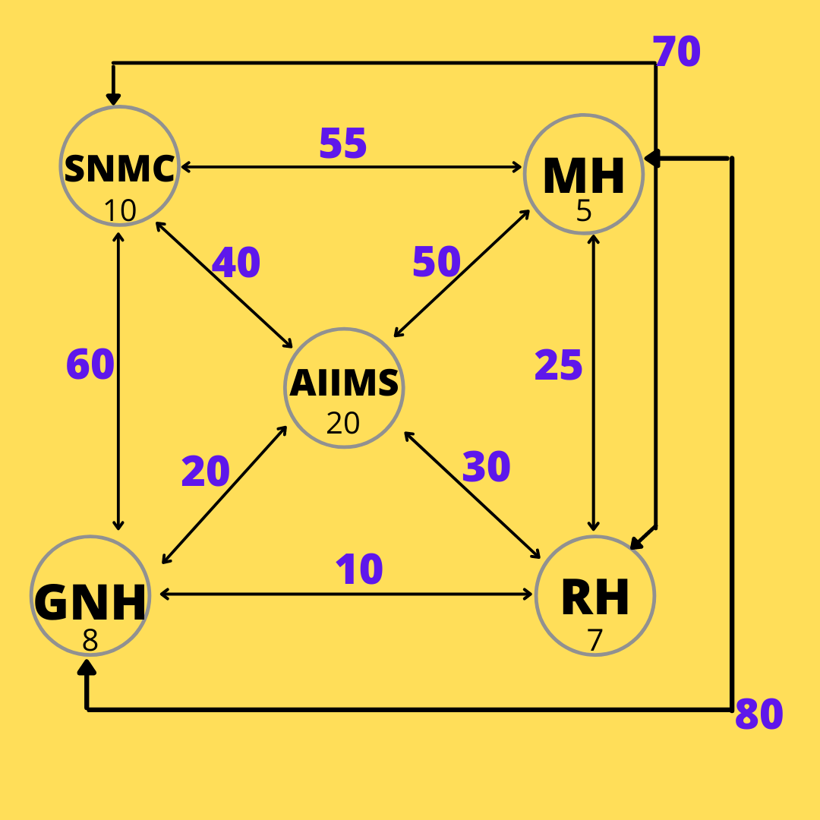

**OUTPUT:**

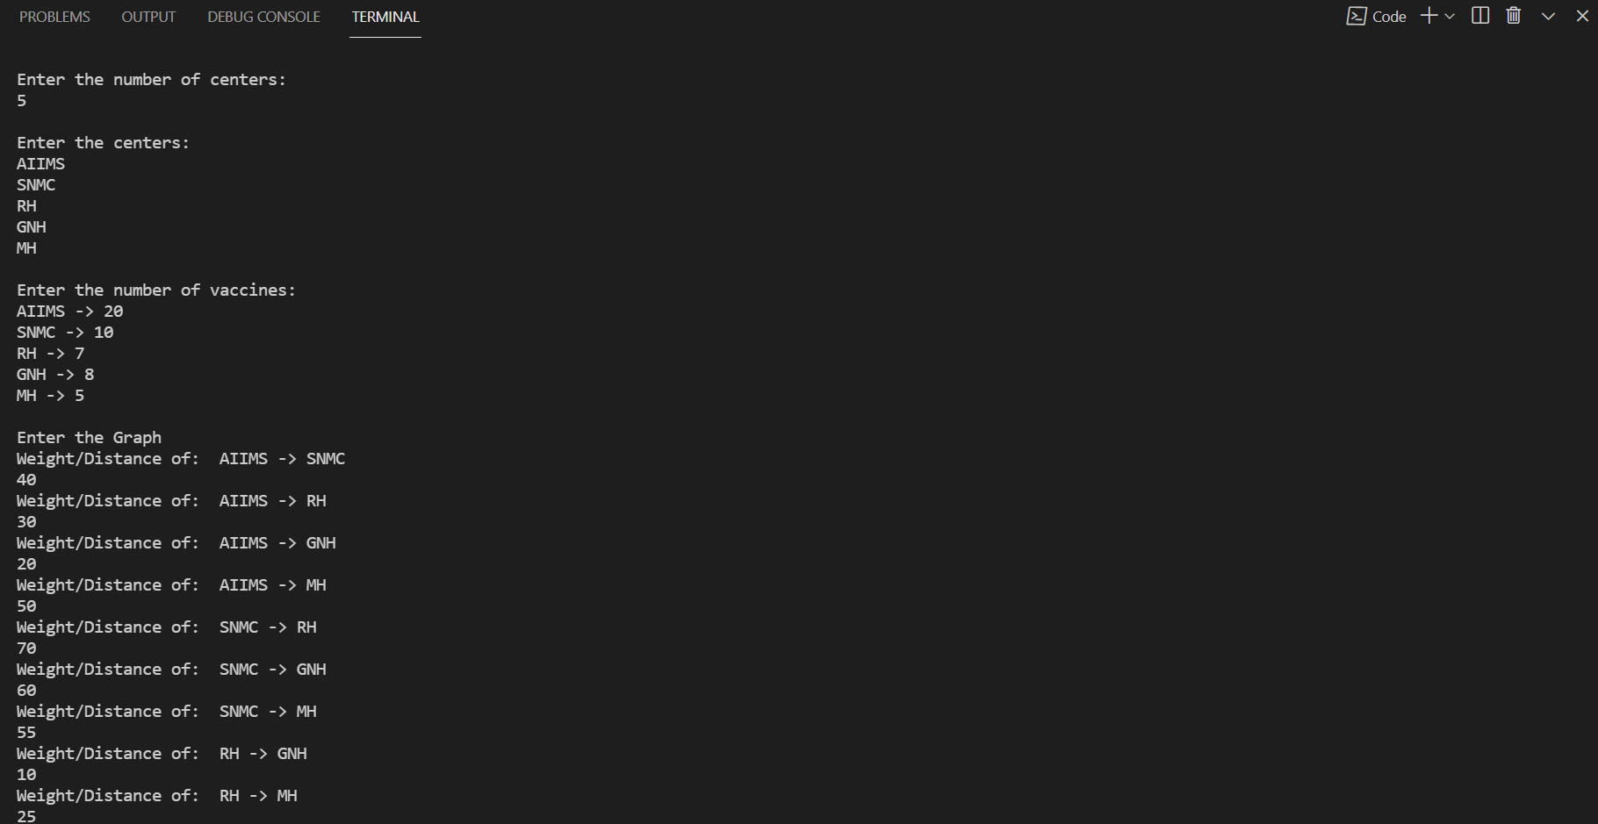

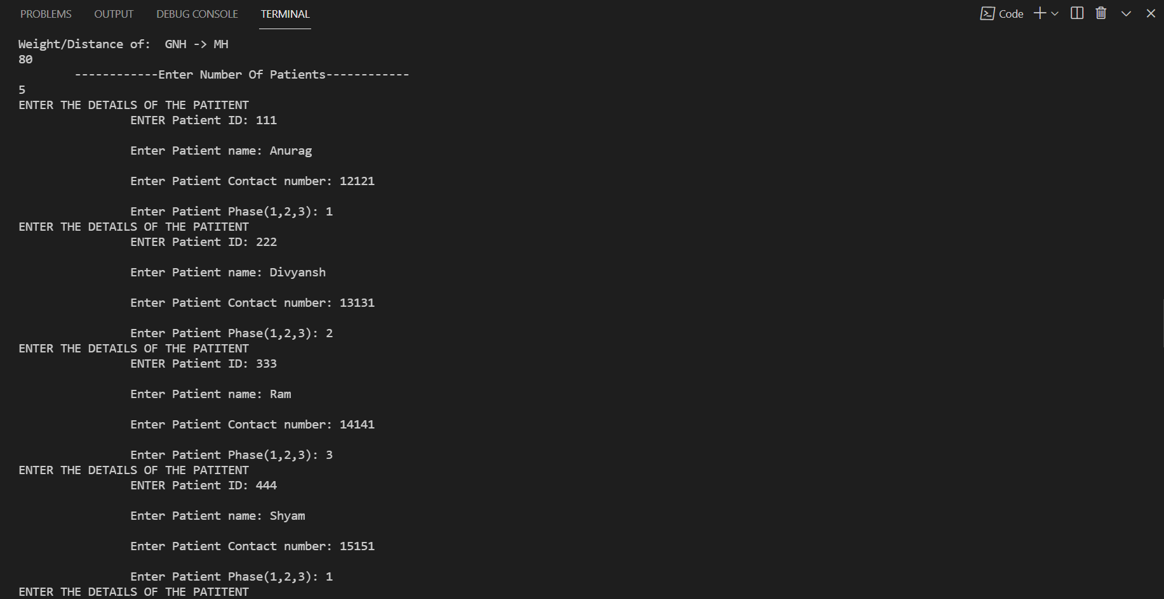

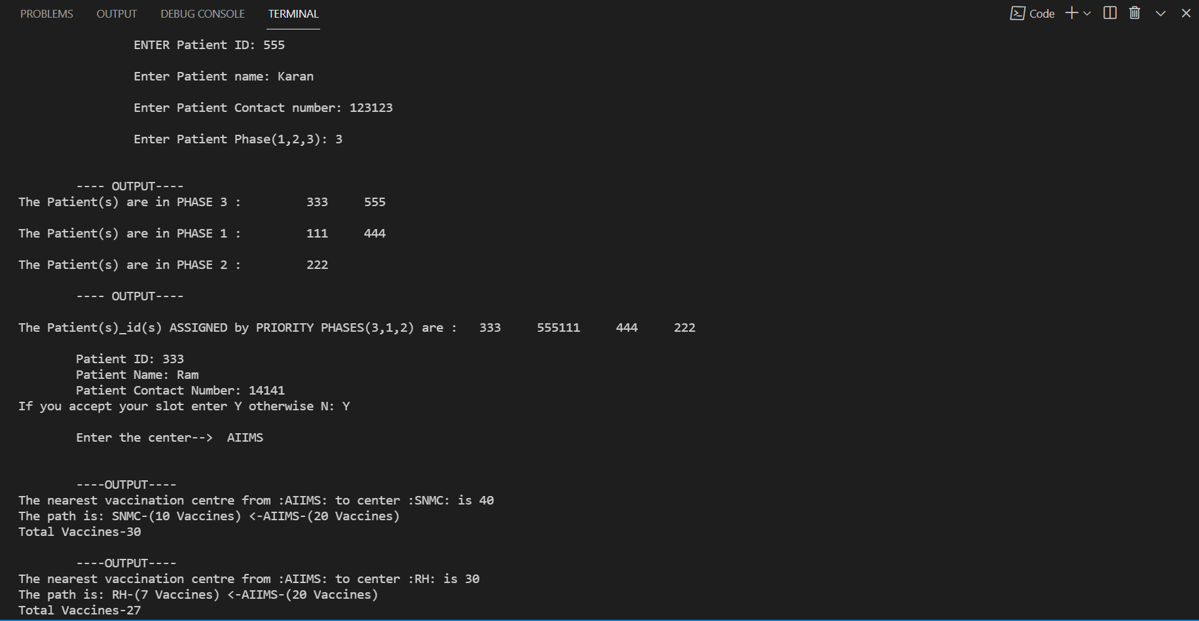

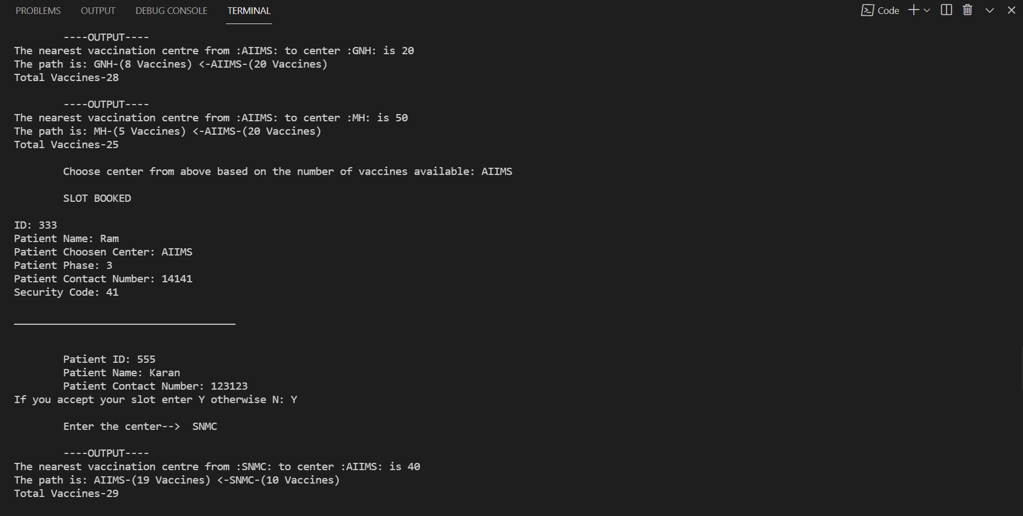

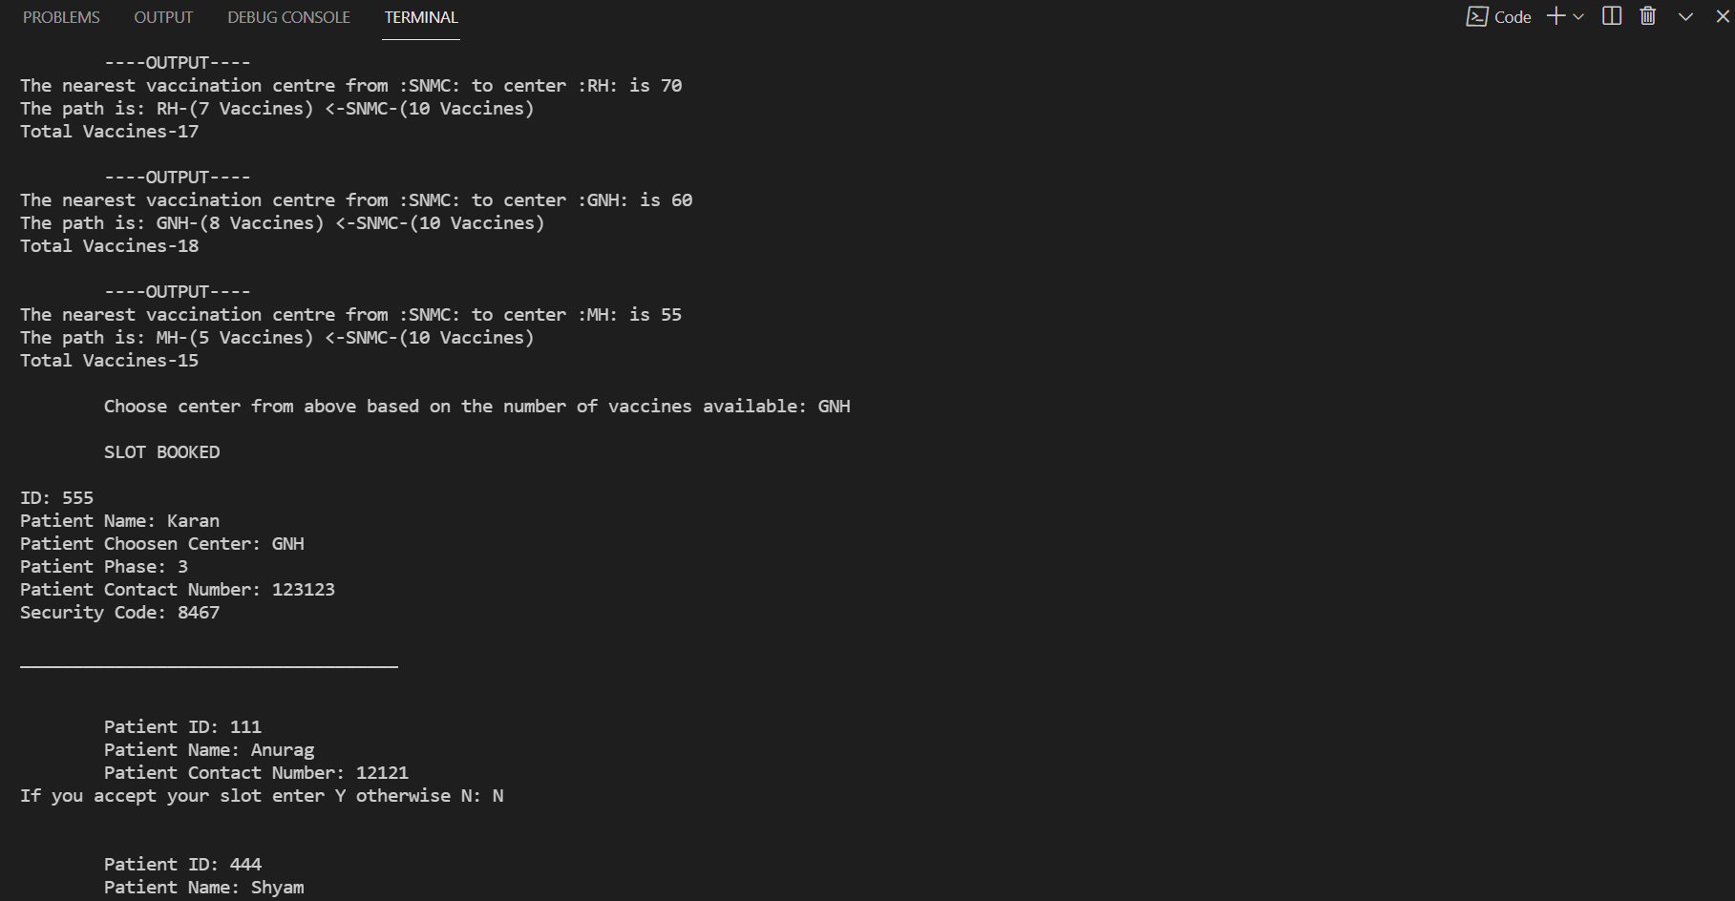

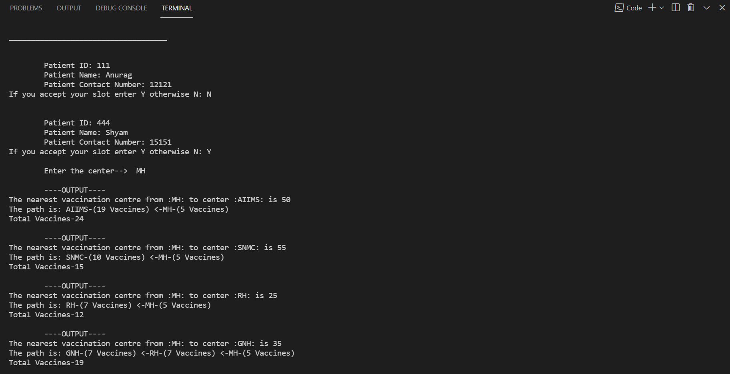

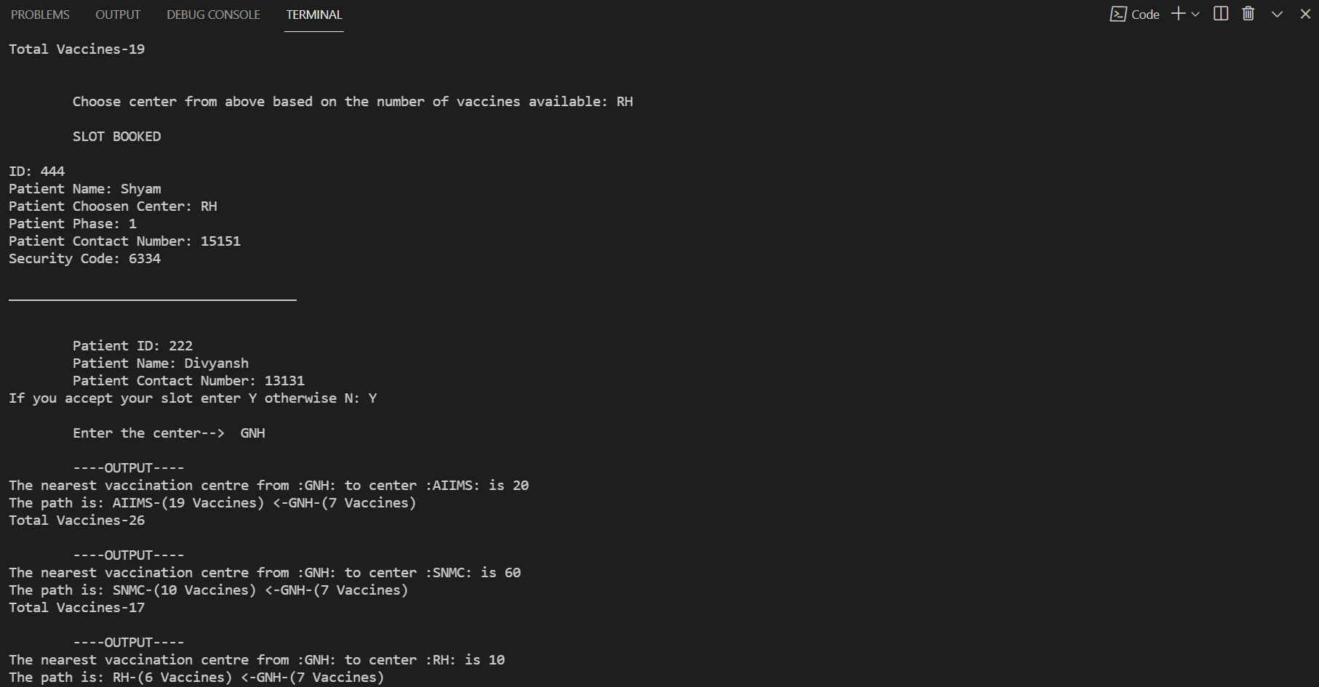

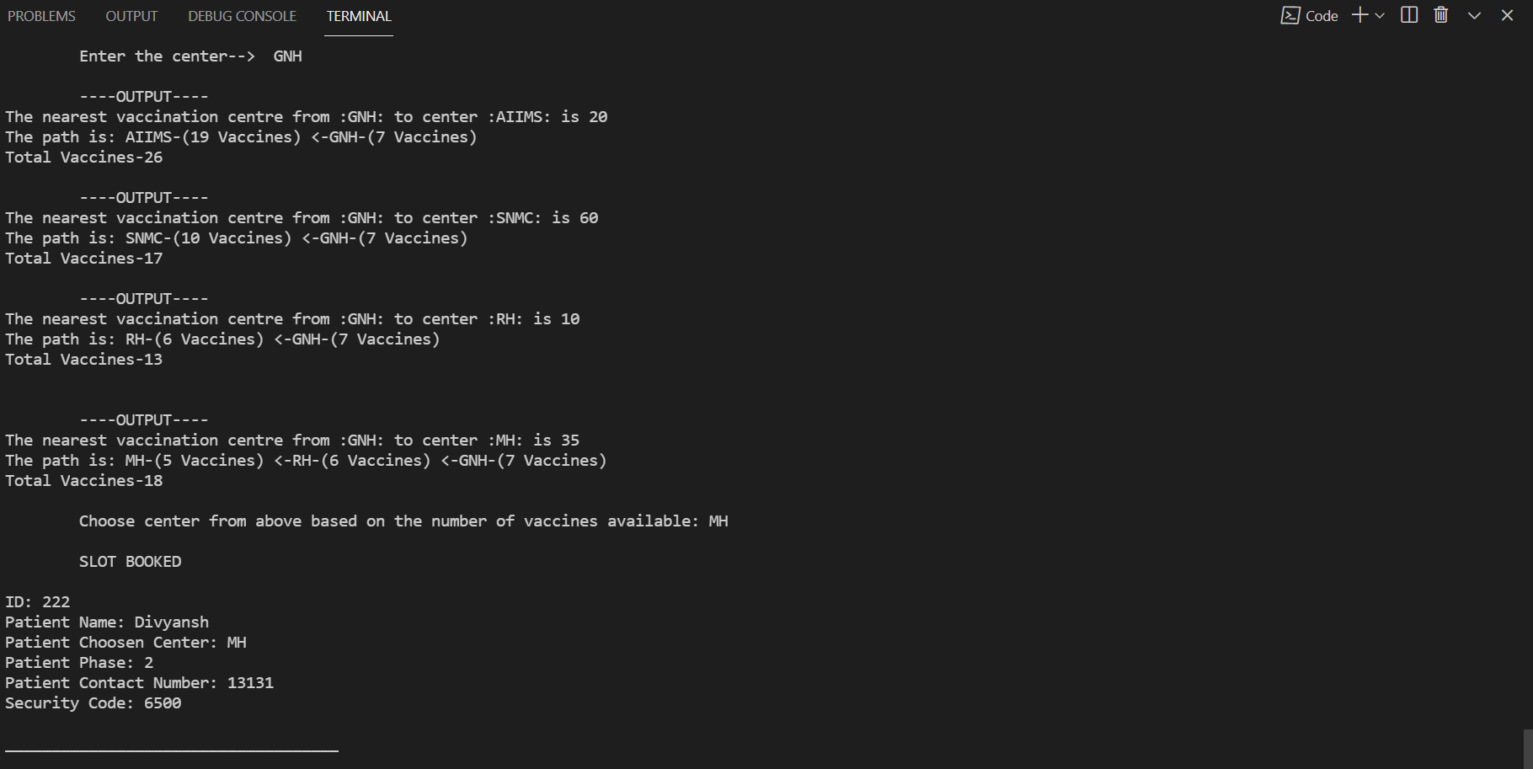

**IMPLEMENTATION DETAILS**

**CODE:**

#include <iostream>

#include<queue>

#include<vector>

#include<stack>

#include<string>

#include<cmath>

#include<map>

#include<bits/stdc++.h>

using namespace std;

class Patient{

public:

    int patient_id;

    string p_name;

    int p_contact;

    int P_condition;

    Patient(){

        cout<<"ENTER THE DETAILS OF THE PATITENT"<<endl;

        cout<<"     ENTER Patient ID: ";

        cin>>patient_id;

        cout<<"\n       Enter Patient name: ";

        cin>>p_name;

        cout<<"\n       Enter Patient Contact number: ";

        cin>>p_contact;

        //1->critical

        //2->below critical

        //3->normal

        cout<<"\n       Enter Patient Phase(1,2,3): ";

        cin>>P_condition;

    }

    //GET PATIENT DETAILS->

    int getPatientCondition()

    {

        return P_condition;

    }

    int getPatientID(){

        return patient_id;

    }

    int getPatientContact(){

        return p_contact;

    }

    string getPatientName(){

        return p_name;

    }

    void getPatientDetails()

    {

        cout<<"\n\tPatient ID: "<<patient_id;

        cout<<"\n\tPatient Name: "<<p_name;

        cout<<"\n\tPatient Contact Number: "<<p_contact;

    }

};

// void getPatientDetailsWithPatientID(int p_id,n,)

//  {

//      for(int i=0;i<n;i++)

//      {

//          if(P[i]->patient_id==p_id)

//          {

//              P[i]->getPatientDetails();

//          }

//      }

//  }

#define MAX 10

#define INF 100000;

void dijk(int G[MAX][MAX], int n, int start, vector<string> centers, vector<int> Vaccine)

{

    int cost[MAX][MAX], dist[MAX], visited[MAX], pred[MAX];

    int i, j, count, mindist, nextnode;

    for (i = 0; i < n; i++)

    {

        for (j = 0; j < n; j++)

        {

            if (G[i][j] == 0)

            {

                cost[i][j] = INF;

            }

            else

            {

                cost[i][j] = G[i][j];

            }

        }

    }

    for (i = 0; i < n; i++)

    {

        dist[i] = cost[start][i];

        pred[i] = start;

        visited[i] = 0;

    }

    dist[start] = 0;

    visited[start] = 1;

    count = 1;

    while (count < n - 1)

    {

        mindist = INF;

        for (i = 0; i < n; i++)

        {

            if (dist[i] < mindist && !visited[i])

            {

                mindist = dist[i];

                nextnode = i;

            }

        }

        visited[nextnode] = 1;

        for (i = 0; i < n; i++)

        {

            if (!visited[i])

            {

                if ((mindist + cost[nextnode][i]) < dist[i])

                {

                    dist[i] = mindist + cost[nextnode][i];

                    pred[i] = nextnode;

                }

            }

        }

        count++;

    }

    for (i = 0; i < n; i++)

    {

        int sum = 0;

        if (i != start)

        {

            cout << "\n ----OUTPUT----\n";

            cout << "The nearest vaccination centre from :" << centers[start] << ": to center :" << centers[i] << ": is " << dist[i] << endl;

            cout << "The path is: " << centers[i] << "-(" << Vaccine[i] << " Vaccines) ";

            sum = sum + Vaccine[i];

            j = i;

            do

            {

                j = pred[j];

                cout << "<-" << centers[j] << "-(" << Vaccine[j] << " Vaccines) ";

                sum = sum + Vaccine[j];

            } while (j != start);

        }

        cout << "\n";

        if(sum!=0){

        cout << "Total Vaccines-" << sum << endl;

        }

    }

}

int getIndex(vector<string> centers, int n)

{

    string x;

    int ind;

    cout << "\n\tEnter the center-->  ";

    cin >> x;

    for (int i = 0; i != n; i++)

    {

        if (centers[i] == x)

        {

            ind = i;

            break;

        }

    }

    return ind;

}

void getGraph(int G[MAX][MAX], vector<string> centers, int n)

{

    for (int i = 0; i < n; i++)

    {

        for (int j = i; j < n; j++)

        {

            if (i != j)

            {

                int X;

                cout << "Weight/Distance of:  " << centers[i] << " -> " << centers[j] << endl;

                cin >> X;

                G[i][j] = G[j][i] = X;

            }

            else

            {

                G[i][j] = 0;

            }

        }

    }

}

void showq(queue<int> gq)

{

    queue<int> g = gq;

    while (!g.empty()) {

        cout << '\t' << g.front();

        g.pop();

    }

    cout << '\n';

}

void makePatientQueue(queue<int> q1,queue<int> q2,queue<int> q3,queue<int> patientQueue)

{

    queue<int> g1 = q1;

    queue<int> g2 = q2;

    queue<int> g3 = q3;

    while (!g1.empty()) {

        patientQueue.push(g1.front());

        g1.pop();

    }

    while (!g2.empty()) {

        patientQueue.push(g2.front());

        g2.pop();

    }

    while (!g3.empty()) {

        patientQueue.push(g3.front());

        g3.pop();

    }

}

// string chooseCenter(vector<string> center,vector<int> vaccine,int n)

// {

//  return cc;

// }

void displaydetails(string cc,int pid)

{

}

int main()

{

    system("CLS");

    //VACCINES centers

    int G[MAX][MAX], n, start;

    int i, j;

    cout << "\n";

    cout << "Enter the number of centers:" << endl;

    cin >> n;

    cout << "\n";

    //centers name

    cout << "Enter the centers:" << endl;

    vector<string> center(10);

    for (int i = 0; i < n; i++)

    {

        cin >> center[i];

    }

    cout << "\n";

    cout << "Enter the number of vaccines:" << endl;

    vector<int> vaccine(10);

    for (int i = 0; i < n; i++)

    {

        cout << center[i] << " -> ";

        cin >> vaccine[i];

    }

    cout << "\n";

    cout << "Enter the Graph" << endl;

    getGraph(G, center, n);

    int m;

    cout<<" ------------Enter Number Of Patients------------"<<endl;

    cin>>m;

    // patients details

    Patient *P[m];

    for(int i=0;i<m;i++)

    {

        P[i]=new Patient;

    }

//# QUEUE A,B,C

    queue<int> q1;

    queue<int> q2;

    queue<int> q3;

    queue<int> patientQueue;

    cout<<endl;

    for(int i=0;i<m;i++){

        if(P[i]->P_condition==3)

        {

            // cout<<"\npatient id:"<<P[i]->patient_id;

            int p=P[i]->patient_id;

            q1.push(p);

        }

        else if(P[i]->P_condition==1){

            // cout<<"\npatient id:"<<P[i]->patient_id;

            int p=P[i]->patient_id;

            q2.push(p);

        }

        else if(P[i]->P_condition==2){

            // cout<<"\npatient id:"<<P[i]->patient_id;

            int p=P[i]->patient_id;

            q3.push(p);

        }

    }

    cout<<"\n   ---- OUTPUT----";

    cout << "\nThe Patient(s) are in PHASE 3 : ";

    showq(q1);

    cout << "\nThe Patient(s) are in PHASE 1 : ";

    showq(q2);

    cout << "\nThe Patient(s) are in PHASE 2 : ";

    showq(q3);

    cout<<"\n   ---- OUTPUT----\n";

    //MAKING A QUEUE THAT STORES PATIENT IDS WITH CONDITION

    // makePatientQueue(q1,q2,q3,patientQueue);

    queue<int> g1 = q1;

    queue<int> g2 = q2;

    queue<int> g3 = q3;

    while (!g1.empty()) {

        patientQueue.push(g1.front());

        g1.pop();

    }

    while (!g2.empty()) {

        patientQueue.push(g2.front());

        g2.pop();

    }

    while (!g3.empty()) {

        patientQueue.push(g3.front());

        g3.pop();

    }

    cout << "\nThe Patient(s)_id(s) ASSIGNED by PRIORITY PHASES(3,1,2) are : ";

    showq(patientQueue);

    // getPatientDetailsWithPatientID(111,3);

    queue<int> patientIDS=patientQueue;

    while(!patientIDS.empty()){

        char choice;

        int PidQueue=patientIDS.front();

        for(int i=0;i<m;i++)

        {

            if(P[i]->patient_id==PidQueue)

            {

                P[i]->getPatientDetails();

                cout<<"\nIf you accept your slot enter Y otherwise N: ";

                cin>>choice;

                if(choice=='Y'){

                start=getIndex(center,n);

                dijk(G, n, start, center, vaccine);

                string cc;

                cout<<"\n   Choose center from above based on the number of vaccines available: ";

                cin>>cc;

                for(int j=0;j<n;j++)

                {

                    if(cc==center[j])

                    {

                        vaccine[j]-=1;

                        // cout<<"\nCOMPARED ANURAG DIVYANSH----------------------";

                        break;

                    }

                }

                cout<<"\n   SLOT BOOKED  \n";

// function call

                cout<<"\nID: "<<P[i]->getPatientID()<<endl;

                cout<<"Patient Name: "<<P[i]->getPatientName()<<endl;

                cout<<"Patient Choosen Center: "<<cc<<endl;

                cout<<"Patient Phase: "<<P[i]->getPatientCondition()<<endl;

                cout<<"Patient Contact Number: "<<P[i]->getPatientContact()<<endl;

                cout<<"Security Code: "<<rand()%10000<<endl;

                cout<<"\n____________________________________\n";

                patientIDS.pop();

                }

                else{

                    patientIDS.pop();

                }

            }

        }

        cout<<endl;

    }

    return 0;

}

**REFRENCES:**

* **Let us C/CPP(Book)**
* **Geeks For Geeks**
* **Kaggle**
* **Google**
* **College Slides**
* **Tutorials point**
* **Beginning C++**
* **C++ STL Libraries**
* **YouTube**
* **Programmiz**

**Declaration Form:**

|  |  |
| --- | --- |
| **Team Number** | 1 |
| **Project Title** | **SARS Cov-2 Vaccination System** |
| **Batch Number** | **B4** |
| **File Name** | **1_SARS_Cov-2_Vaccination_System_.dox** |

**Contribution Details**

|  |  |  |  |  |
| --- | --- | --- | --- | --- |
| **Sno** | **Roll Number** | **Name** | **E-mail** | **Contribution in this work (write your contribution in this work such as task done, tools explored, knowledge gained and presented, etc.)** |
| **1**  **2** | **19103150**  **19103127** | **Anurag Singh**  **Divyansh Bhargava** | [**19103150@mail.jiit.ac.in**](mailto:19103150@mail.jiit.ac.in)  [**19103127@mail.jiit.ac.in**](mailto:19103127@mail.jiit.ac.in) | **I, Anurag contributed in this project by presenting this project and learned many new things about data structures, graphs, Classes and Objects, algorithms, dynamic programming and got a chance to explore deep into the field of computer science.**  **I, Divyansh contributed in this project by presenting this project and learned many new things about OOPs, C++, DSA and specially graphs. I explored various applications of dijkstra while working on this project.** |

**Declaration**

**I/We hereby declare that this submission is my/our own work and that, to the best of my knowledge and belief, it contains no material previously published or written by another person nor material which has been accepted for the award of any other degree or diploma of the university or other institute of higher learning, except where due acknowledgment has been made in the text. I/We accept the use of the material presented in this report for Education/Research/Teaching purpose by the faculty.**

|  |
| --- |
| **Signature** |
| **Name : Anurag Singh Name : Divyansh Bhargava**  **Date & Place: 20-July-2021 –WFM poject Date & Place: 20-July-2021 – WFM Project** |